1. In Virtualbox, create a second hard disk with capacity of **20 GB** as shown.

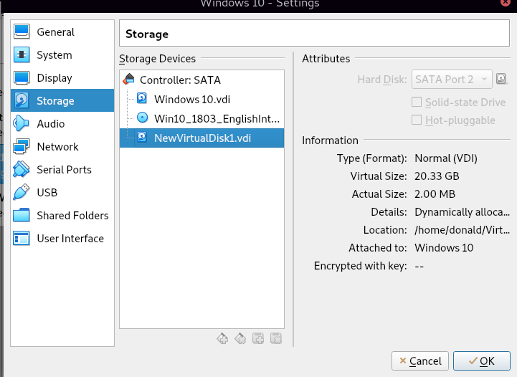

1. Start up Windows 10 and access Disk Management. Format **Disk1** to use the NTFS file system. Set the volume label to **BACKUP**.

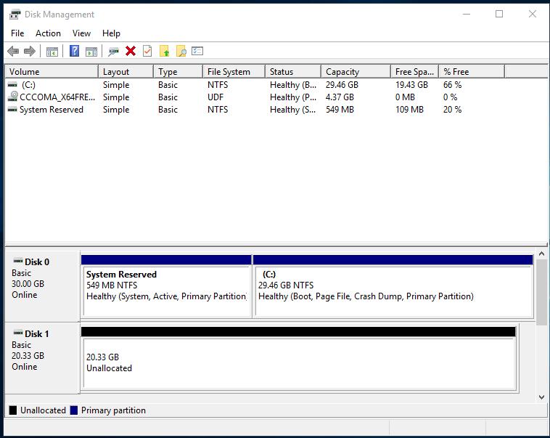

After formatting Disk 1, you should see the second disk formatted to NTFS as shown below. This will be the Backup Disk.

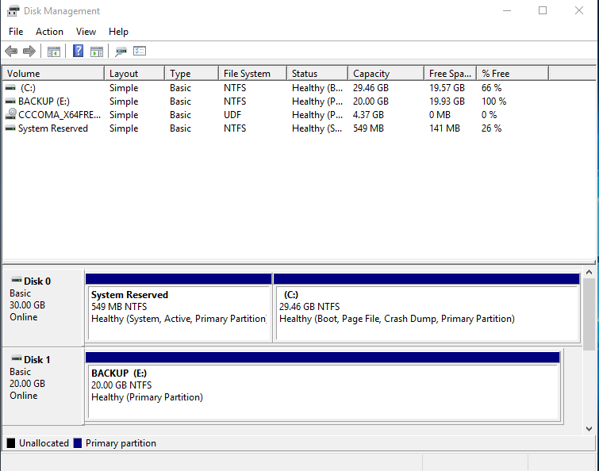

1. Access **Control Panel** in Windows 10. Open up **Backup and Restore (Windows 7)**.
2. Create a **System Image** and have it backed up on hard disk labelled **BACKUP**. Backup the **System Reserved (System)** and **C:** volumes. If you get prompted to create a system disc, click **No**. Verify on the BACKUP drive that you have the System Image stored there.

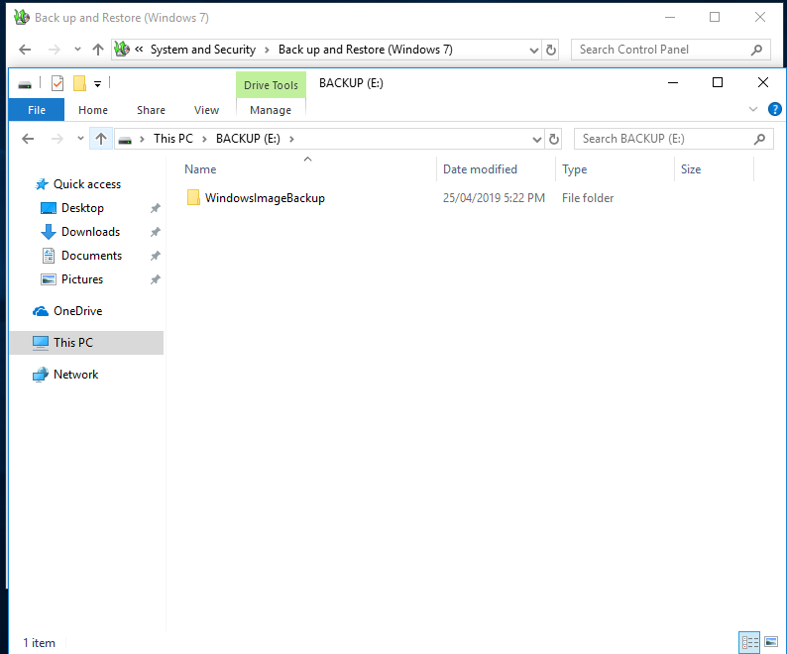

1. Restart the Windows 10 and boot off the iso file. Choose **Repair your computer**. Then go to **Troubleshoot**. Perform a **System Image Recovery** of Windows 10. Format all disks before performing a recovery.
2. Verify that you can boot off the Windows 10 operating system after the recovery is complete.